2. spring-rest-handson
iii) REST - Get country based on country code
country.xml:
<?xml version="1.0" encoding="UTF-8"?>
<beans xmlns="http://www.springframework.org/schema/beans"
xmlns:xsi="http://www.w3.org/2001/XMLSchema-instance"
xsi:schemaLocation="http://www.springframework.org/schema/beans
https://www.springframework.org/schema/beans/spring-beans.xsd">

<bean id="countryList" class="java.util.ArrayList">
<constructor-arg>
<list>
<bean class="com.cognizant.springlearn.model.Country">
<property name="code" value="IN" />
<property name="name" value="India" />
</bean>
<bean class="com.cognizant.springlearn.model.Country">
<property name="code" value="US" />
<property name="name" value="United States" />
</bean>
<bean class="com.cognizant.springlearn.model.Country">
<property name="code" value="UK" />
<property name="name" value="United Kingdom" />
</bean>
<bean class="com.cognizant.springlearn.model.Country">
<property name="code" value="AU" />
<property name="name" value="Australia" />
</bean>
</list>
</constructor-arg>
</bean>

</beans>

CountryService interface :
package com.cognizant.springlearn.service;

import com.cognizant.springlearn.model.Country;

public interface CountryService {

Country getCountry(String code);

}

CountryServiceImpl :
package com.cognizant.springlearn.service;

import java.util.List;

import org.slf4j.Logger;
import org.slf4j.LoggerFactory;
import org.springframework.context.ApplicationContext;
import org.springframework.context.support.ClassPathXmlApplicationContext;
import org.springframework.stereotype.Service;

import com.cognizant.springlearn.model.Country;

@Service
public class CountryServiceImpl implements CountryService {

private static final Logger logger = LoggerFactory.getLogger(CountryServiceImpl.class);

@Override
@SuppressWarnings("unchecked")
public Country getCountry(String code) {
logger.info("===== Entering getCountry() method =====");

ApplicationContext context = new ClassPathXmlApplicationContext("country.xml");
List<Country> countryList = (List<Country>) context.getBean("countryList");
((ClassPathXmlApplicationContext) context).close();

Country matchedCountry = countryList.stream()
.filter(country -> country.getCode().equalsIgnoreCase(code))
.findFirst()
.orElse(null);

logger.info("===== Exiting getCountry() method =====");
return matchedCountry;
}

}

CountryController.java :
package com.cognizant.springlearn.controller;

import org.slf4j.Logger;
import org.slf4j.LoggerFactory;
import org.springframework.beans.factory.annotation.Autowired;
import org.springframework.context.ApplicationContext;
import org.springframework.context.support.ClassPathXmlApplicationContext;
import org.springframework.web.bind.annotation.GetMapping;
import org.springframework.web.bind.annotation.PathVariable;
import org.springframework.web.bind.annotation.RequestMapping;
import org.springframework.web.bind.annotation.RequestMethod;
import org.springframework.web.bind.annotation.RestController;

import com.cognizant.springlearn.model.Country;
import com.cognizant.springlearn.service.CountryService;

@RestController
public class CountryController {

private static final Logger logger = LoggerFactory.getLogger(CountryController.class);

@Autowired
private CountryService countryService;

@RequestMapping(value = "/country", method = RequestMethod.GET)
public Country getCountryIndia() {
logger.info("===== Entering getCountryIndia() method =====");

ApplicationContext context = new ClassPathXmlApplicationContext("country-config.xml");
Country india = context.getBean("india", Country.class);
((ClassPathXmlApplicationContext) context).close();

logger.info("===== Exiting getCountryIndia() method =====");
return india;
}

@GetMapping("/countries/{code}")
public Country getCountry(@PathVariable String code) {
logger.info("===== Entering getCountry() method =====");

Country country = countryService.getCountry(code);

logger.info("===== Exiting getCountry() method =====");
return country;
}

}

Running SpringLearnApplication.java :
package com.cognizant.spring_learn;
import java.text.ParseException;
import java.text.SimpleDateFormat;
import java.util.Date;

import org.springframework.context.ApplicationContext;
import org.springframework.context.support.ClassPathXmlApplicationContext;

import org.slf4j.Logger;
import org.slf4j.LoggerFactory;
import org.springframework.boot.SpringApplication;
import org.springframework.boot.autoconfigure.SpringBootApplication;

@SpringBootApplication(scanBasePackages = {"com.cognizant.springlearn", "com.cognizant.springlearn.controller"})
public class SpringLearnApplication {

private static final Logger logger = LoggerFactory.getLogger(SpringLearnApplication.class);

public static void main(String[] args) {
logger.info("===== Entering main() method of SpringLearnApplication =====");
SpringApplication.run(SpringLearnApplication.class, args);
logger.info("===== SpringLearnApplication started successfully =====");
displayDate();
}
private static void displayDate() {
ApplicationContext context = new ClassPathXmlApplicationContext("date-format.xml");

SimpleDateFormat format = context.getBean("dateFormat", SimpleDateFormat.class);

try {
Date date = format.parse("31/12/2018");
System.out.println("Parsed date: " + date);
} catch (ParseException e) {
e.printStackTrace();
}
}
}
Browser Output:
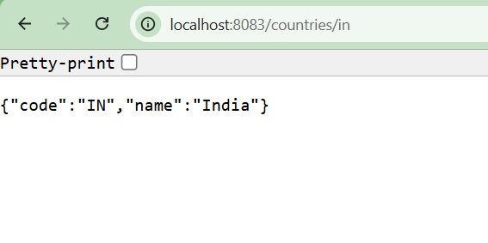 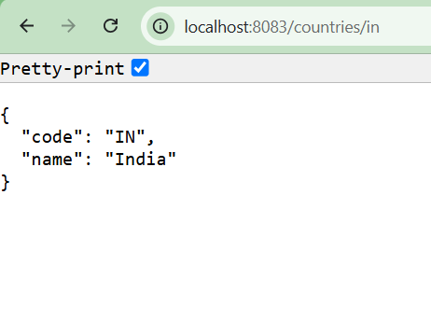Postman Output:
